Computer Communication networks

GROUP 13

IMAGE DRIVEN TALKING HEAD

Iteration 13

Till iteration 2, we set up the environment and checked whether the model is working or not. Now in iteration we developed a graphical user interface locally which helps to take the input in real-time and creates a database and gives output according to it.

We chose web-RTC to deploy our project. This is easier than an app. This web-based interface directly communicates with the user. As this is an image driven model, we used haar cascade algorithm which is better for face detection and analysis.

We developed a graphical user interface with basic requirements. As the project model prefers set of .png files in a folder better than .mp4 or gif files, we use this GUI to capture approximately 300 images using our webcam and storing them in our database along with their unique names for each folder. These .png files usage helps us to reduce the loss function and gives better I/O performance than other formats. We created a folder to save all the data in folders. These files helps us to get our required output. These images help us in training the base image and making it animated in realtime. We used face detector, classifier, create data set file. App.gui file is the main file of all these which is responsible for working of the GUI interface.

Till iteration 3, we developed the local interface. In iteration 4 and iteration 5, we integrate this with web interface (still developing) and with the model and deploy the model and get real time outputs.

The current output is show in screenshots below and a video link is also attached. The total project file will be uploaded in the GitHub after completing which is easier

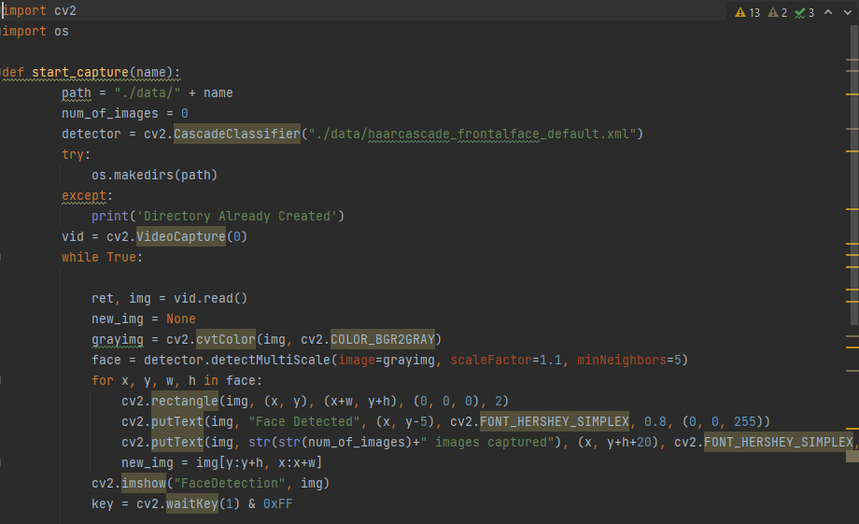

Creating a dataset

the dataset has been created for the various functionalities in the Graphical user interface. With the use of the dataset, different data could be leveraged that will cater to the requirements of the final Graphical User Interface (GUI).

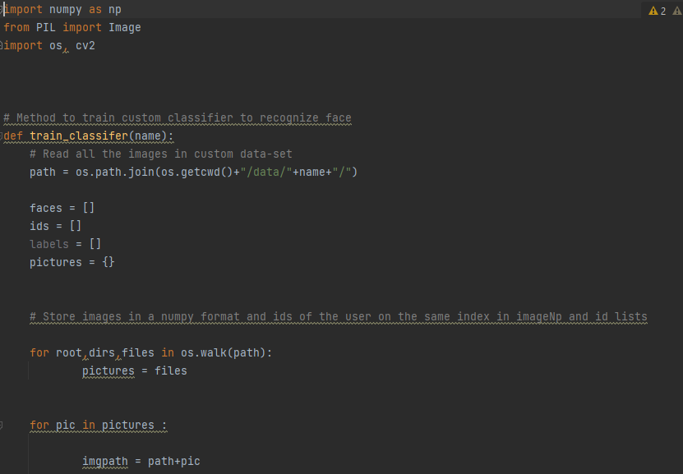

Creating a classifier within the GUI

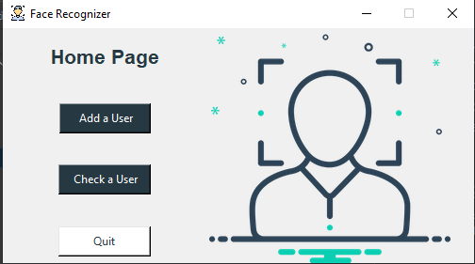

GUI for face recognition

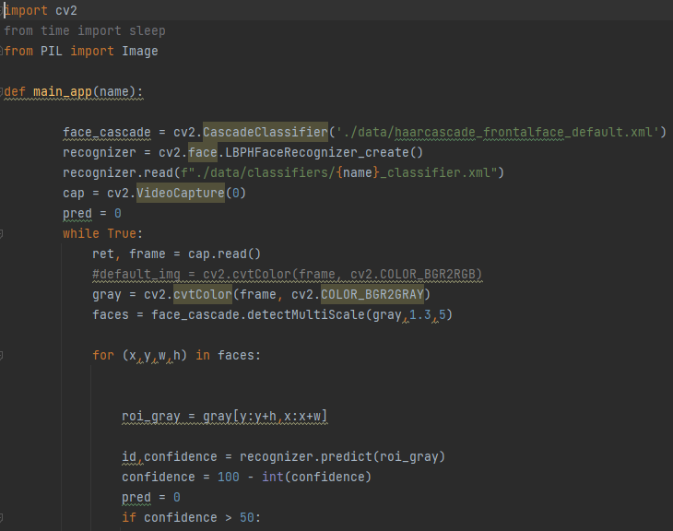

Face detector code

## Youtube link for working of GUI:

* <https://youtu.be/S9H3D5AVBKk>